Student Name: Click here to enter text.
Access Code (located on the lid of your lab kit): Click here to enter text.
Pre-Lab Questions
”1. Name two functions of the nasal cavity mucosa.”
Click here to enter text.
”2. Why is the trachea reinforced with cartilaginous rings? ”
Click here to enter text.
”3. Describe the path a molecule of oxygen takes to get to body tissue, starting with the nares. ”
Click here to enter text.
”4. What is asthma? ”
Click here to enter text.
Experiment 1: Microscopic Anatomy of the Respiratory System
Table 1: Experimental Observations
Respiratory Image | Description of Visible Structure(s)
Trachea | Click here to enter text.
Lung | Click here to enter text.

Post-Lab Questions
”1. Label the arrows in the slide images below. ”
A- Click here to enter text.
B- Click here to enter text.
C- Click here to enter text.
D- Click here to enter text.
E- Click here to enter text.
F- Click here to enter text.
G- Click here to enter text.
H- Click here to enter text.
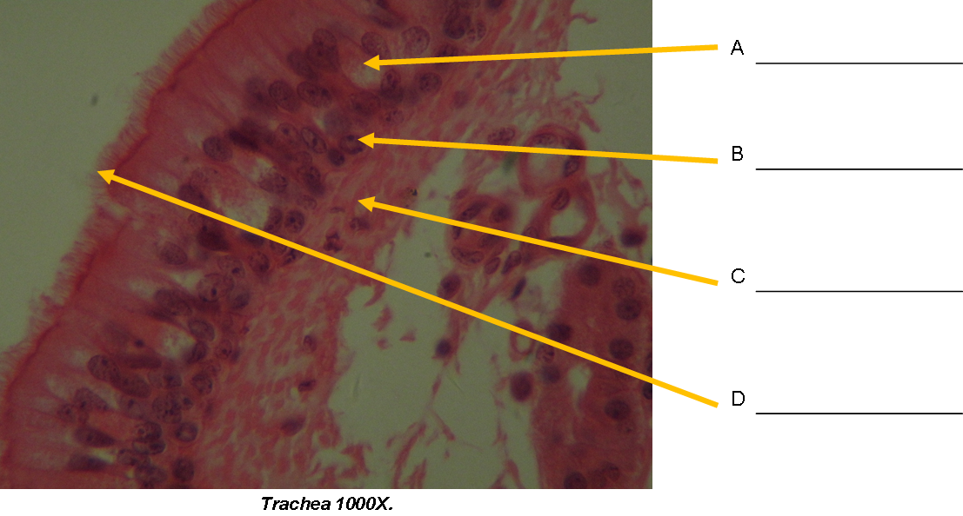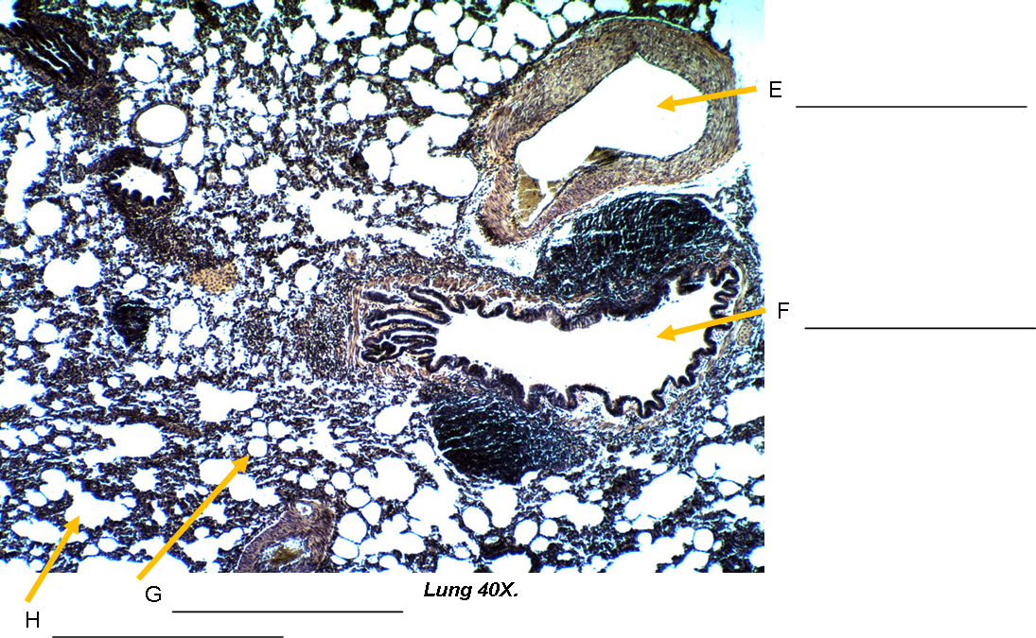

”2. What structural features of alveoli make them an ideal place for gas exchange? ”
Click here to enter text.
”3. Why is mucus present in the trachea? ”
Click here to enter text.
”4. What is the specific function of the cilia on the walls of the trachea? ”
Click here to enter text.

Experiment 2: Virtual Model – The Respiratory System
”1. How many diaphragm(s) exist in the human body? ”
Click here to enter text.
”2. Does deoxygenated blood become oxygenated in the upper respiratory tract, the lungs, or the diaphragm? ”
Click here to enter text.
”3. Is the trachea superior or inferior to the diaphragm? ”
Click here to enter text.
”4. Is the heart (located in the mediastinum) or the right lung more medial to the body? ”
Click here to enter text.
”5. What is the most inferiorly located organ of the respiratory system? ”
Click here to enter text.
Experiment 3: Virtual Model – Respiratory System Coloring Activity
”Insert Respiratory System – Anterior View image here: ”

Experiment 4: Understanding Lung Mechanics
Table 2: Understanding Lung Mechanics Observations
Squeezed Bottle Observations (Step 3) | Released Bottle Observations (Step 4)
Click here to enter text. | Click here to enter text.

Post-Lab Questions
”1. What happens to the balloon? Why? ”
Click here to enter text.
”2. What would happen if the seal at the base of the bottle leaked? ”
Click here to enter text.
”3. What causes a collapsed lung? ”
Click here to enter text.
”4. Is a collapsed lung functional? Why or why not? ”
Click here to enter text.
Experiment 5: Peak Flow Meter
Table 3: Peak Flow Meter Data
Trial | Normal | Post-Exercise
1 | Click here to enter text. | Click here to enter text.
2 | Click here to enter text. | Click here to enter text.
3 | Click here to enter text. | Click here to enter text.
Highest Reading | Click here to enter text. | Click here to enter text.
Post-Lab Questions
”1. What changes were observed after the volunteer exercised? ”
Click here to enter text.
”2. Did the PEF increase or decrease? Explain why this change occurred; be sure to incorporate physiological reasoning in your explanation. ”
Click here to enter text.
Experiment 6: Fetal Pit Dissection: The Respiratory System
Post-Lab Questions
”1. Describe the interior lining of the trachea. ”
Click here to enter text.
”2. What role do the rings of cartilage surrounding the trachea play? ”
Click here to enter text.
”3. Were there many or few vessels serving as conduits between the lungs and the heart? Why is this important? ”
Click here to enter text.
”4. Describe the function of the diaphragm during inhalation and exhalation. ”
Click here to enter text.

”Insert photo of your pig’s exposed lungs with your name clearly visible in the background: ”

